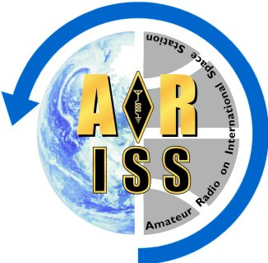

Amateur Radio on the International Space Station

Release Forms Requirement

Amateur Radio on the International Space Station (ARISS) requests that each school participating in a contact submit to the program, audio, photographs and video of the event. A signed ARISS Release Form is required for each student participating in the contact or whose name, likeness or voice is captured in these media.

Once the permission slips have been signed by the students, or their guardians if the students are minors, the school will scan all signed release forms in pdf format and e-mail the forms to:

school.selection.manager@ariss-eu.org

